
The minutes of the meeting of Satterthwaite Parish Council, in the Parish Room, Satterthwaite on Monday 19th January 2026 at 7.30 pm.

Agenda
Item
Opening Administration
1 | Welcome and Introductions  Apologies  Mhairi Crabtree  Suzanne Pender arrived 20:02
2 | Declarations of interest  - To receive declarations by elected and co-opted members of disclosable pecuniary interests in respect of items on this agenda  None
3 | Requests for Dispensations  - The clerk to report any requests received since the previous meeting for dispensations to speak and/or vote on any matter where a member has a disclosable pecuniary interest.  None
4 | Minutes  - To authorise the Chair to review and sign last meetings minutes on 1st of December 2025  Accepted as accurate record
Matters for consideration
5 | Public participation  - To receive comments and representations from members of the public in relation to any item on the agenda  None present
6 | Updates on ongoing issues and actions from last meeting  Review of action log  - LDNPA and Dale Park caravan update – CEO replied and court case been opened. Inspection from LDNPA last week for new dwelling and case been opened.  - Playground quotes – seeking 3 quotes for pavilion for playground.  - Zurich insurance – awaited confirmation.  - Observatory visit plans for community – awaiting reply on pricing pp.  - Village Parking – planners visited 19/01/26, awaiting update  - Moor lane and motorcyclists – will be a barrier placed at bottom but work on drainage also due by National Park.  - Standing Orders/Financial regs – in progress.  - Meeting with HIAMS - tbc
7 | Items for meeting not covered above  - Governance review draft report – see item 18  - Gritting - £500 authorised to Hawkshead as our contribution for gritting, £331 still in credit to date. Will continue to monitor.
8 | Additional or urgent points to raise regarding Parish or Councillor matters  - Fibrus and road closures – Suzanne Pender will draft a formal complaint due to frequency of road closures to W&F, to be sent as a joint response from herself and PC. Potentially escalte to ombudsman if not a satisfactory response.  - Malcolm Wilson rally – want to use both sides of Grizedale as cannot use Whinlatter this year. To raise concerns re: traffic associated through village and no previous consultation with Parish Council.
9 | Items for the Lengthsman  Nothing currently
Planning
10 | Planning Consultations sought from Parish Council  Wall removed at entrance area behind church. Some groundworks complete including grass cutting and removal of tree stump.  Sign required to stop parking which blocks entrance to field. If planning unsuccessful, can be used as a village amenity instead.
Finance
11 | Accounts since last meeting  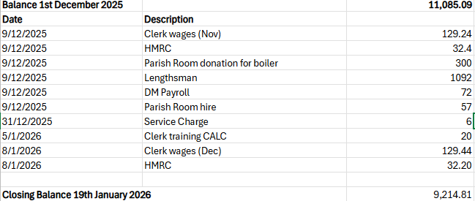  To sign off invoices for removal and modification of dry-stone wall on green behind church £1332 - approved
12 | Precept  £44.91 in 24/25 and dropped to £35.93 this year. Plan to put back to £44.91 per property for 26/27.
Key correspondence, consultations and reports not covered above
13 | Cumbria CVS – flood sacks - noted
14 | W&F anti-social behaviour plans – flag a car that is staying in Dale Park and fly tipping. Will try to get registration number of car.
15 | W&F long distance walking trail - noted
16 | Removal of Sport England as statutory consultee in planning - noted
17 | W&F Annual Budget Consultation – noted.
18 | Community Governance review – Draft report – final report going to W&F Council meeting 22/01/26 – Colton and Satterthwaite suggested an interest in grouping together however a factual inaccuracy in Colton’s suggestion ‘group or merge’ is incorrect as they only asked to group with Satterthwaite. The final report recommends that Colton and Satterthwaite merge. Suzanne Pender will raise concerns on our behalf and local Parishes as not taken into account wishes. Clerk to write letter to be read in Council this week by Cllr Pender on our behalf.
19 | Internal audit service EOI - will compare prices when known, for this service by CALC.
Council calendar
20 | Games night to be arranged – 7th Feb 6pm – posters to be distributed, email communications  Observatory visit to be arranged – observatory will get back to us re: price per person
Closing administration
21 | Agenda items for next meeting
22 | Next meeting date to be agreed  - 2nd March 2026 7:30pm Satterthwaite Parish Room  - 20th April 2026 7:30pm Satterthwaite Parish Room

